Practical - 13

Practical Title: PHP JSON API and AJAX/Fetch-Based CRUD without Page Reload

Problem Definition: Create simple PHP JSON API endpoints for events or students and
consume them using Fetch API. Perform list, add, update, and delete operations
asynchronously without full page reload.

Theory :
1. Do PHP endpoints return valid JSON responses?
Yes. Each endpoint sets the header Content-Type: application/json and returns the response
using json_encode(). The response contains a status, a message and the data. The output can
be checked in the Network tab of the browser.

2. Are GET and POST requests handled properly?
Yes. GET requests are used to list records, and POST requests are used to add, update and
delete records. The endpoint checks $_SERVER['REQUEST_METHOD'], and for an
unsupported method it returns an error response in JSON.

3. Are loading, success, and error states shown on the frontend?
Yes. A "Loading ... " message is shown while the fetch request is running. After the response,
the data is rendered and a success message is shown. If the response is not OK or the request
fails, the error is handled using .catch() and an error message is displayed on the page.

4. Is input validation performed before database operations?
Yes. The PHP endpoint checks required fields, valid email format and numeric id, and trims
the input before using it. Prepared statements are used for the queries, and for invalid input a
JSON error message is returned instead of running the query.

Add Students:-
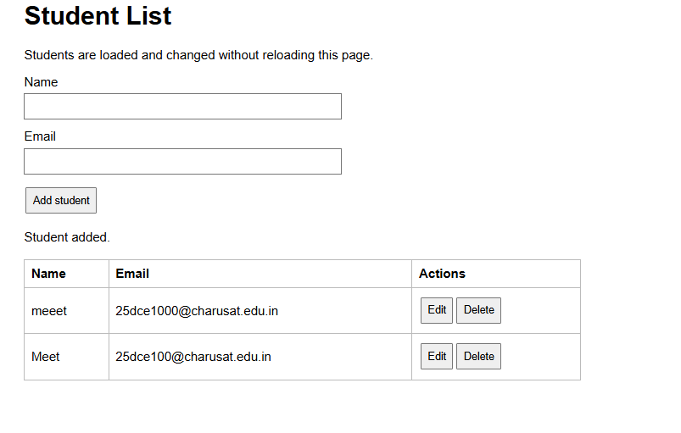
Update student Details:
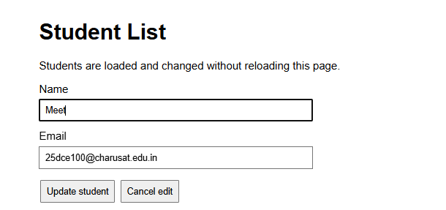

Delete Student Details:

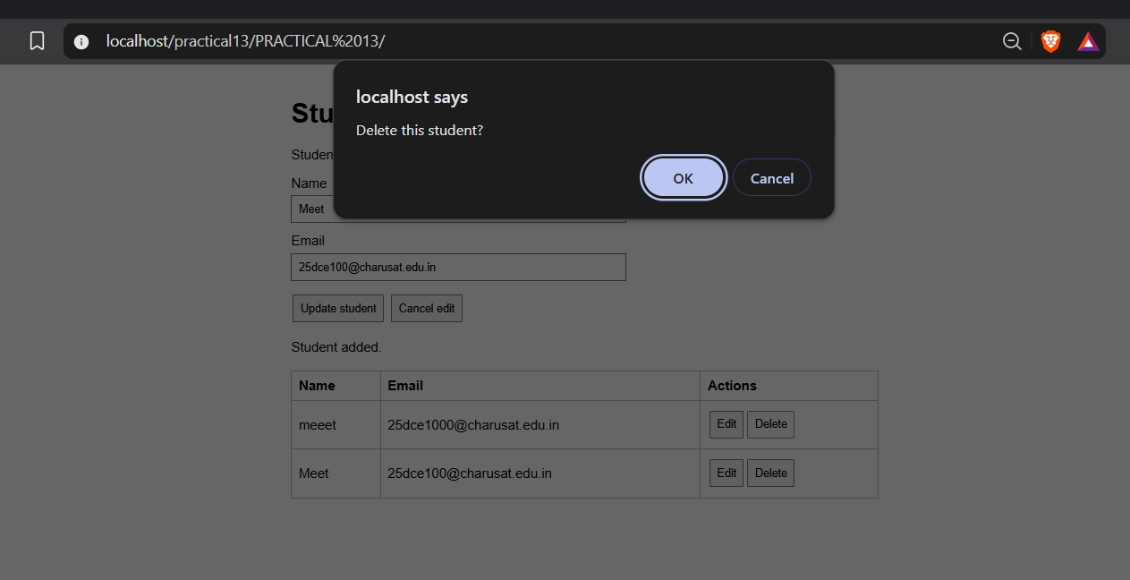

Repository Link :-
https://github.com/meet-3834/Student-Hub/tree/main/FINAL%20Submission

- Learning Outcomes:
I am able to integrate frontend JavaScript with PHP backend using JSON
APIs.

Faculty Remarks: (Keep this blank for faculty)

